7-Day Theatre Workshop
Organized by the Department of Mass Communication, Integral University, Lucknow
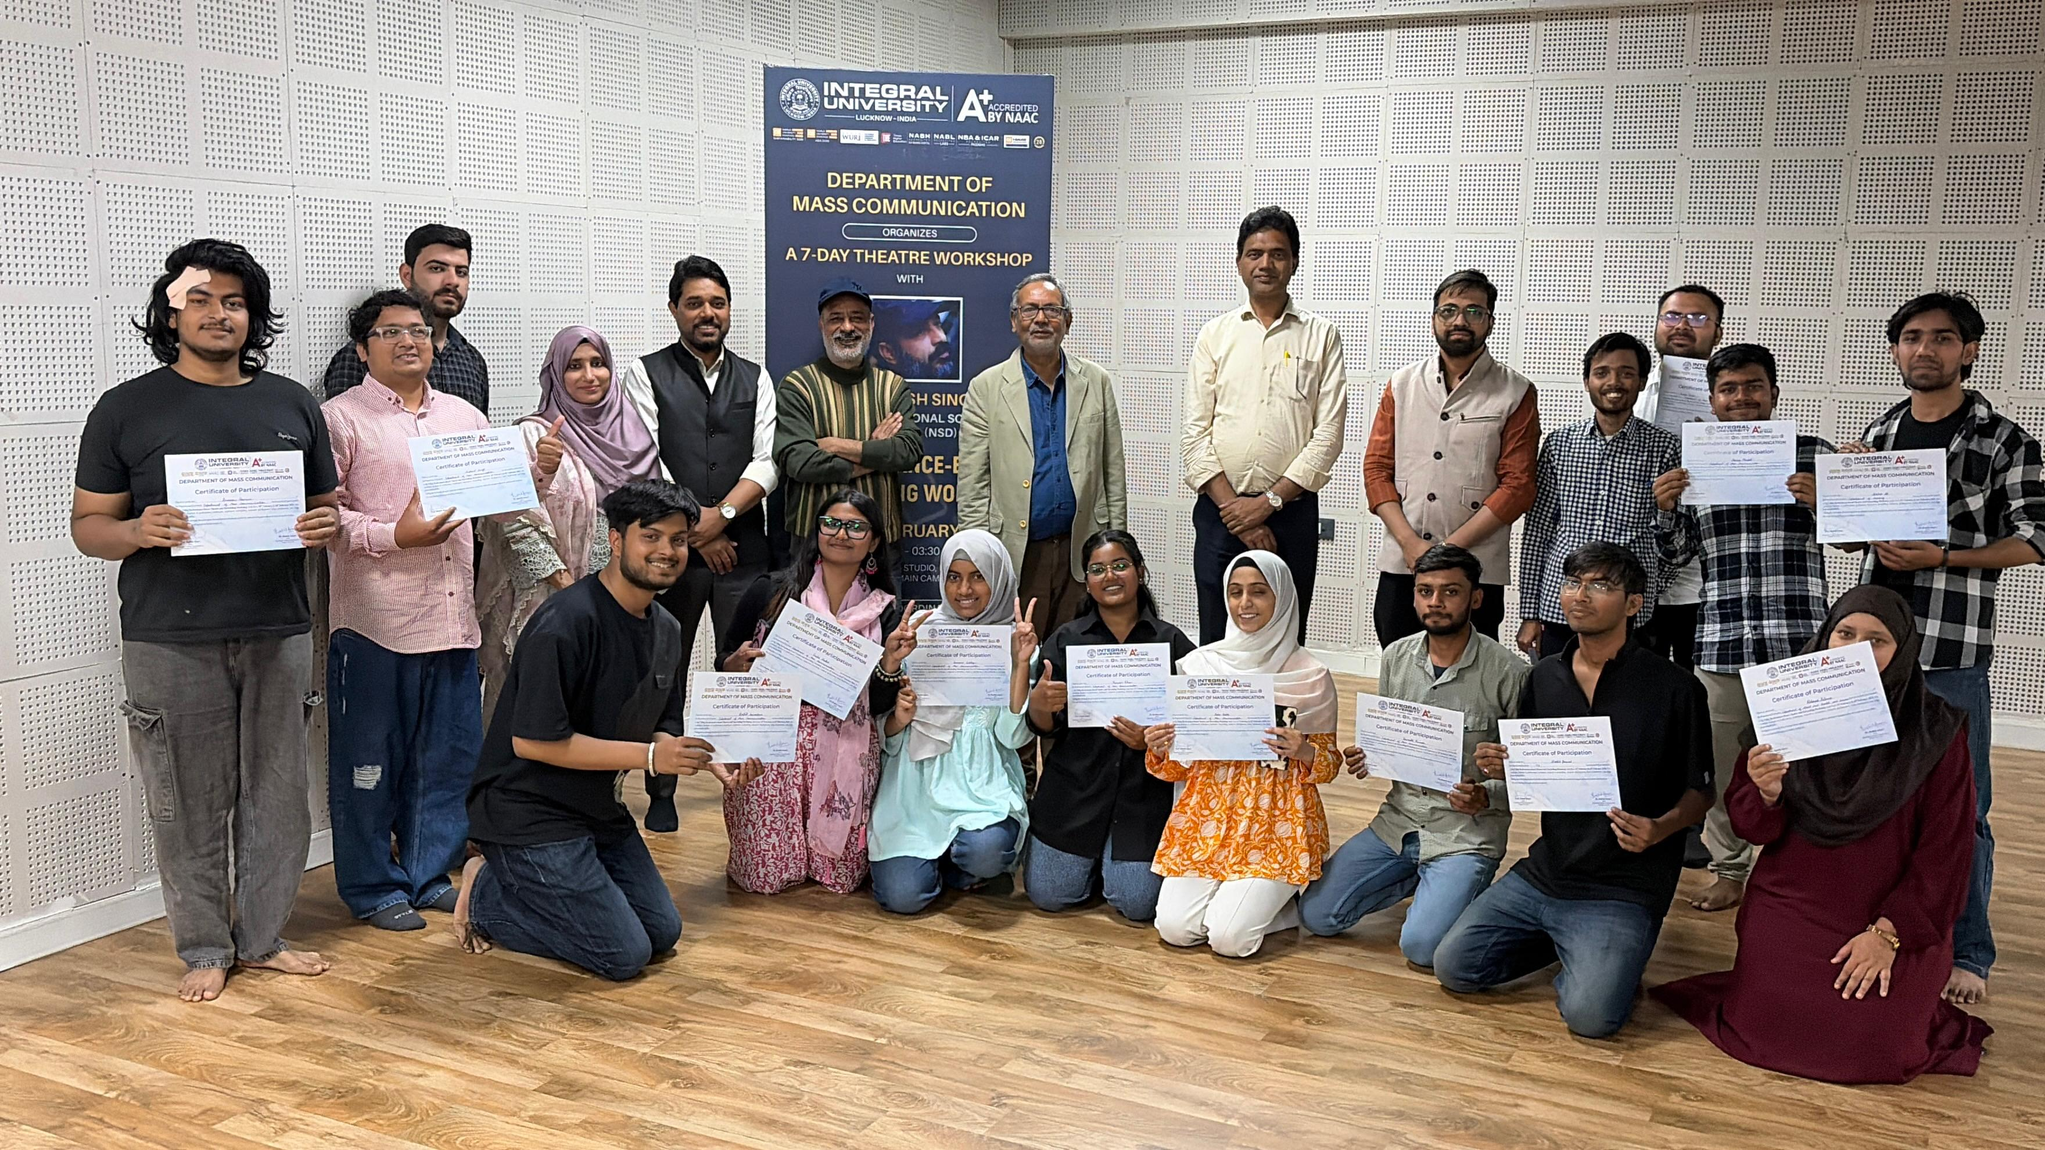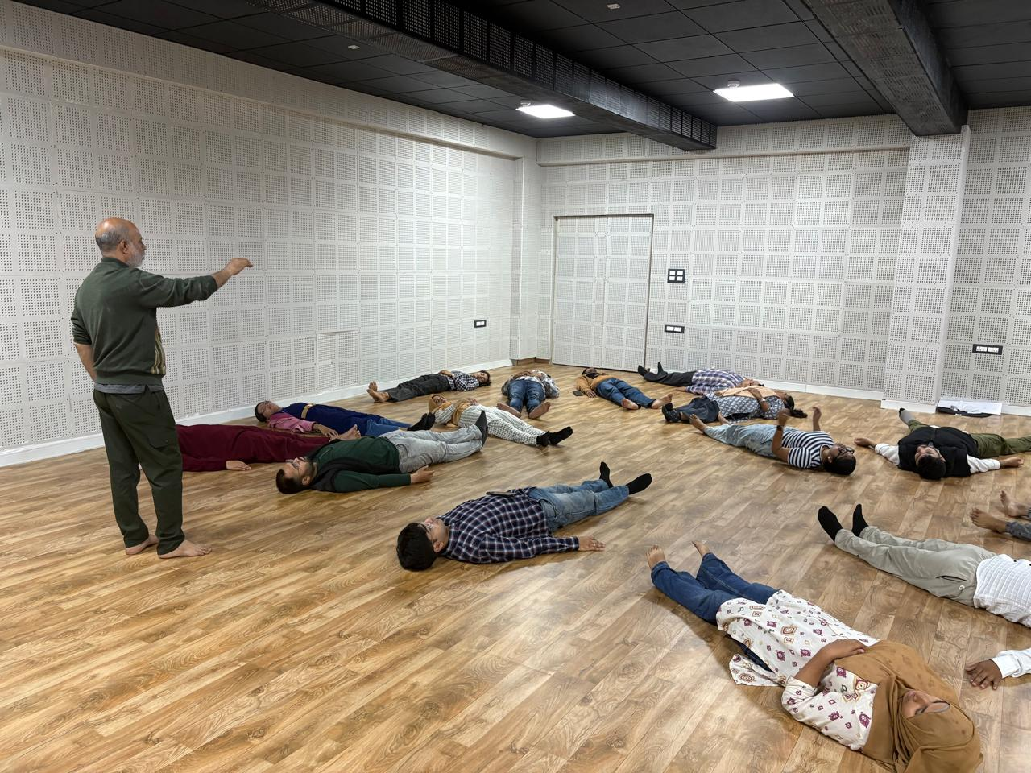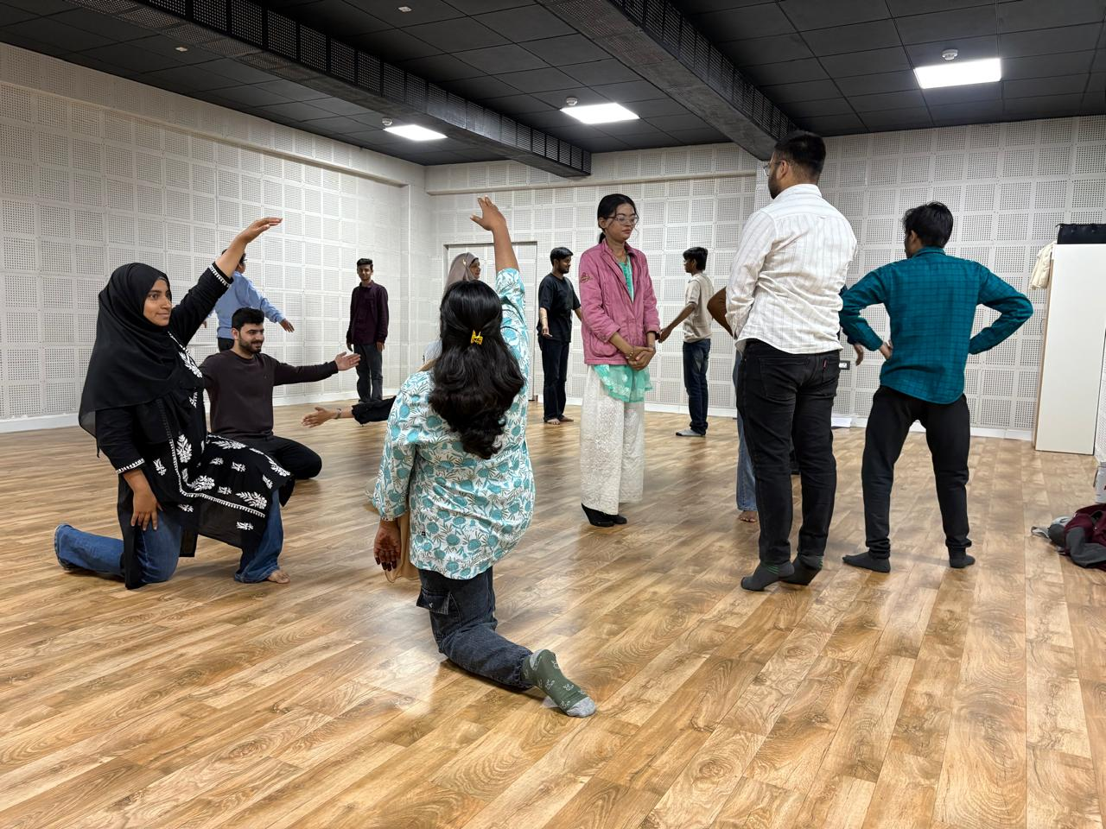

The Department of Mass Communication at Integral University, Lucknow, organized a 7-day Theatre Workshop on Performance-Based Storytelling from 19 February to 26 February 2026 in the Television Studio. The workshop was conducted by Mr. Rakesh Singh, an alumnus of the prestigious National School of Drama (NSD), who brought extensive experience in theatre practice, acting, and performance training.
The workshop aimed to introduce students to the fundamentals of performance-based storytelling, an expressive form that blends narrative techniques with theatrical performance. The sessions were designed to help students develop confidence, creativity, and communication skills while learning the essential elements of theatre such as performance techniques, expressive storytelling, voice modulation, body language, and character development. Through these components, participants were encouraged to understand how emotions, gestures, dialogue delivery, and physical expression work together to create impactful stage performances.
The workshop was conducted daily from 1:30 PM to 3:30 PM and consisted of a series of practical exercises, demonstrations, and interactive learning sessions. Students actively participated in voice training, breathing and articulation exercises, body movement practices, improvisational activities, and storytelling exercises. These activities allowed participants to explore how a simple narrative can be transformed into a compelling theatrical presentation using dramatic expression, movement, and improvisation.
More than 40 students from various departments of Integral University, along with participants from other institutions, took part in the workshop. The participation from different academic backgrounds created an engaging and collaborative learning environment where students could exchange ideas and explore diverse approaches to storytelling and performance.
Under the guidance of Mr. Rakesh Singh, participants worked both individually and in groups to develop short storytelling pieces and theatrical scenes. The workshop emphasized creative interpretation, teamwork, stage presence, and character portrayal, enabling students to gain practical exposure to the discipline of theatre. On the final day of the workshop, the participants presented a short theatrical play, showcasing the skills and techniques they had learned during the training. The performance highlighted their understanding of expressive storytelling, character building, and stage coordination.
A Valedictory Ceremony was organized on 9 March 2026, where participants were felicitated and awarded Certificates of Participation in recognition of their enthusiastic involvement and successful completion of the workshop. The ceremony marked the culmination of a highly engaging and enriching learning experience that encouraged students to explore theatre as a medium of creative expression and storytelling.

Thanks & With Warm Regards

Dr. Rashid Ansari
Head, Department of Mass Communication
Integral University, Lucknow

